1. **Advantages**. 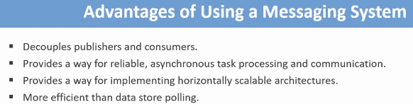
   1. **Decouples publishers and Consumers**: **Message publisher and Message Processor applications** don’t need to know each other. They don’t need to k now each other’s IP address and in which technology they are implemented.  
      All they need to know is about the message format which is usually JSON data.
   2. **Provides a way for reliable, asynchronous task processing and communication**: Publisher can publish messages even if no consumer app is running. All the messages are cared of and saved. So the consumer app can carry them later. Even if publisher is not online, the response can be resent later.  
      If consumer is not able to process a message, it can be resent or sent to some other consumer until it’s processed.
   3. **Provides a way for implementing horizontally scalable architectures**: If the existing consumers are not enough to process messages, you can run more consumers. System can act as a load balancer among the consumer for more efficient processing.
   4. **More efficient than data store polling**: Periodically polling the data store for new tasks or messages is a slow process and increases the workload of the data store. Messaging system helps you eliminate this problem.
2. **Use Cases**
   1. **First Case🡺E-commerce** website needs to update its **search index** when the product catalogue changes. E-commerce website has many products and there is a **search service** which **indexes** all the information about the products. Website visitors can search products using keywords. When a new product is added or existing one is removed or details of a product is updated, the **search service’s** index must be updated. **Product Service** publishes email/messages when a change happens in product catalog. The **search service** gets the event message from the queue and updates its index accordingly and **asynchronously**.  
      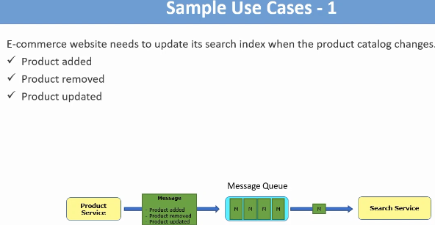
   2. **Second Case🡺**E-commerce needs to send emails to its customers for various reasons such as to validate its customers or to reset password or to inform that order has been created successfully or to inform that the status of the order has changed or to inform about the current or upcoming promotions. **Promotion Service** creates email and sends to **message queue** and **email sender service** gets email tasks from the queue and sends them to the customers email ‘s address **asynchronously**. 